Circular Memo.No.1
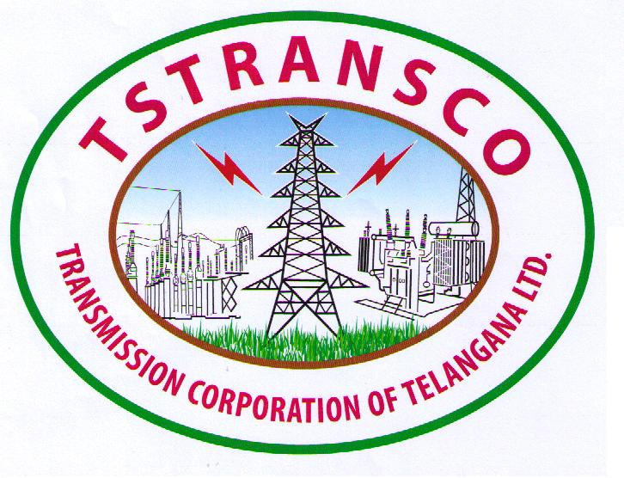
TRANSMISSION CORPORATION OF TELANGANA LIMITED
VIDYUT SOUDHA :: HYDERABAD – 500082
(Website: transco.telangana.gov.in CIN No.U40102TG2014SGC094248)

Circular.Memo.No.JS/DS(Per.II)/AS(IR&Reg)/PO(Reg)/821/14, dt.16.05.2018.

Sub: TSTRANSCO – REGULATIONS - RAMZAN Festival – Permission to all the Employees of TSTRANSCO and Out-Sourcing/Artisans belonging to Muslim Religion to leave Offices early by an hour during the month of RAMZAN from 17.05.2018 to 16.06.2018 (both days inclusive) – Permission - Accorded.

Ref: Circular Memo No.406/Spl.E/2018 dt.15-5-2018 received from Chief Secretary to Govt., General Administration (Spl.E) Department.

* * *
All the Employees belonging to Muslim religion including Out-Sourced/Artisans working in the Offices under the control of TSTRANSCO are permitted to leave their Offices at 4.00 PM on all working days during the month of “RAMZAN” i.e., from 17.05.2018 to 16.06.2018 (both days inclusive) to perform necessary rituals, except when their presence is required due to exigencies of services during the said period.

2. These orders are also available on TSTRANSCO website and can be accessed at the address www.tstransco.in

D.PRABHAKAR RAO
CHAIRMAN & MANAGING DIRECTOR

To
The Executive Directors ]
All Chief Engineers. ]
Chief General Manager(HRD)/OSD ]
Joint Secretary ] TSTRANSCO
FA & CCA/Dy.CCA ]
All Superintending Engineers. ]

All Divisional Engineers/Executive Engineers ]
Copy to:
PS to Chairman & Managing Director/TSTRANSCO/VS /Hyderabad.
PS to JMD(Finance, Comml., & HRD)/TSTRANSCO/VS/Hyderabad.
PS to Director (Projects & Grid Operation) /TSTRANSCO/VS/Hyderabad.
PS to Director(Lift Irrigation Schemes)/TSTRANSCO/VS/Hyderabad.
PS to Director(Transmission)/TS TRANSCO/VS/Hyderabad.
The PS to Chairman and Managing Director/TSSPDCL, Hyderabad.
The PS to Chairman and Managing Director/TSNPDCL, Warangal
All Chief General Managers (HRD)/TSSPDCL & TSNPDCL.
The Pay Officer/ The Accounts Officer/CPR/TSTRANSCO/VS/Hyderabad.
The Company Secretary/TSTRANSCO/VS/Hyderabad.
The Resident Audit Officer, EBCA/TSTRANSCO/VS/Hyderabad.
The Deputy Secretaries// All Asst. Secretaries /TSTRANSCO/VS/Hyderabad.
All Sections in P&G Services/TSTRANSCO/VS/Hyderabad.
The stock file

// FORWARDED BY ORDER //

PERSONNEL OFFICER

